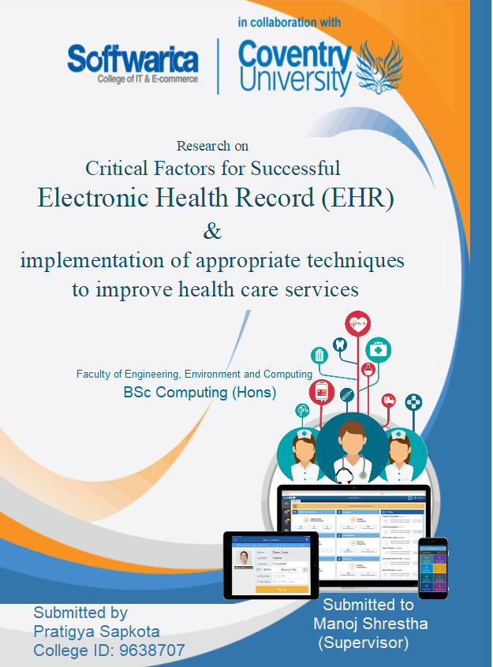

Total word count without bibliography: (2479- 459) = 2020 words.

# Primary research question

These are the list of question to be focus while doing the research.

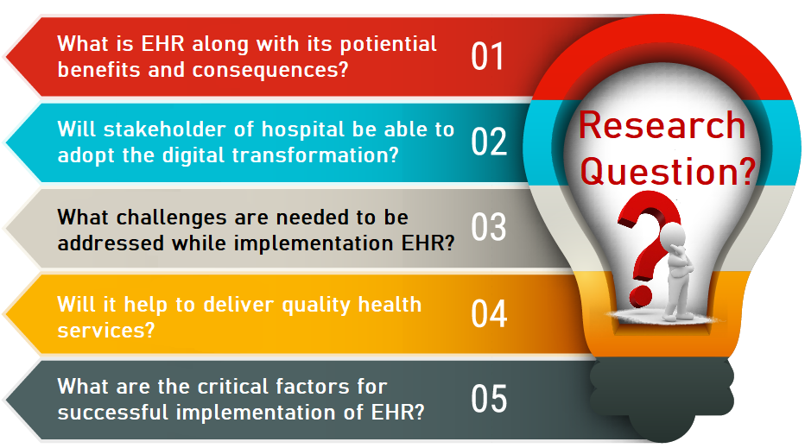

# Topic

Research on Critical Factors for successful EHR and implementation of appropriate techniques to improve health care services

# Keywords

Critical Factor; Electronic Health Records (EHRs); medical informatics; healthcare transformation; patient perspectives; computerized decision support; doctor perspectives;

# Abstract

Digitalization serves as a catalyst to transform every sector towards digital world and it delivers various reforms in each and every sectors of development. Because of the positive impact brought by digitalization, nowadays people heavily rely on technology. The proposed research paper depicts the value of digitalization in health services. In this report, there is discussion about the introducing digitalization in health services, obstacles to face while implementation, existed problem which can be solved by digital transformation and various methods in which digitization can be implemented. The main vision of proposed research is to aware how can this digitalization make impact on the life of people.

# Introduction

Many remarkable technological progresses have been achieved with the convergence of portable and powerful computing devices. The wave of digitalization has flown over the world but analyzing the present context of Nepal, we are still little backward in adopting such techniques of maintaining patient digital records as both the private and government health sectors i.e. hospitals are maintaining their all records like registration, prescription and many more files after files in paper which inconveniently occupies the large number of storages. In the age of technologies, different health sectors are still following the old trend of storing patient data in paper-based system which is bringing enormous problems in patient’s life like time consuming, huge lines, untraceable and sometimes even inaccurate diagnosis.

With the view of fostering the digital health development, the government of Nepal is sharing hands with government of Germany by bringing Nepali-German Health Program (*Health Facility* 2019). But as most of people from age group (50 years to above) are not that familiar with newly born technologies so there might be some difficulties in implementing the concept of EHR (Electronic Health Record). An EHR is a digital version of storing patient’s data which helps to acquire information instantly and can be shared to many other health care setting in a secured way (*Electronic Health Records* 2019). Electronic Health records can be defined in either way electronic patient records (EPRs) or electronic medical records (EMRs). So, in order to find the actual impact by the digitalization my research project is proposed.

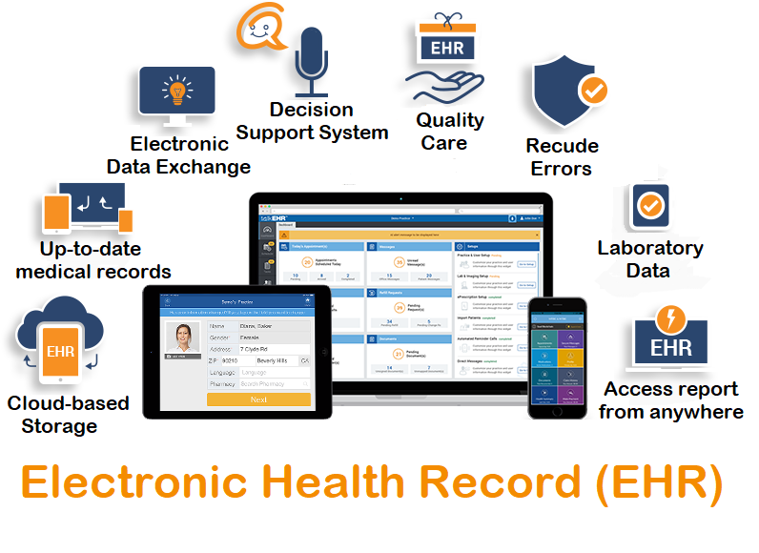

Figure 1: Proposed System

# Aim

To research on impact of Digital Transformation of health facilities and implementation of usable digital solution in web platform from research outcomes.

# Objective

## Personal objective

* To get knowledge about what exactly digitalization is and its impact.
* To collect knowledge about digitalization and its impact by studying various offline and online resources.
* To develop web-based application that provides digital solution.
* To submit research paper and usable web application.

## Technical objective

* To enrich knowledge about using various design tools for developing rich pictures, block diagram, use cases, prototype of the application and many more.
* To use Microsoft project, visual paradigm and many more project management tools.
* To develop a web application with high security.

## Academic objective

* To meet the criteria set by University and submit a well-managed research paper along with usable web-based application.
* To get a degree with good grade.

# Justification of the project

## Problem Statement

As health care is the critical place, many problems arise over there every day. Many patients are suffering from the similar problem shown below as the digital transformation is not adopted by most of the health care. Here, in the below scenario, a girl is accidently hit by the public vehicle while crossing the road. After the accident, the girl had over flow of bleeding and was on critical condition. A man on the road saw her and took her to the hospital. She was laid down to the bed and as the doctor is unaware about her blood group, she takes out sample blood and wait for lab result so that she can give her blood. But before the lab result came, the girl passed away.

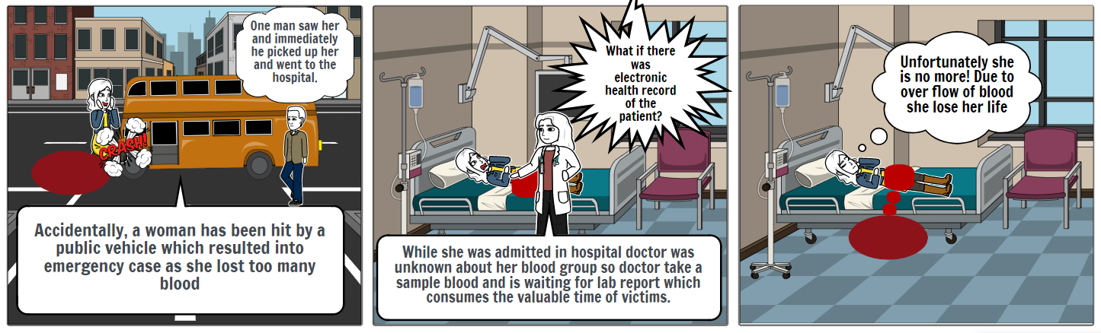

Figure 2: Problem statement

## Solution to the problem

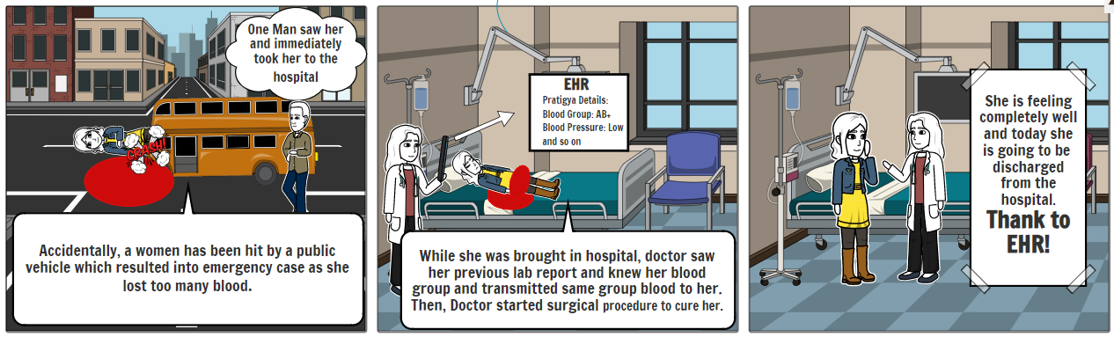The solution to the above-mentioned problem probably could be the digitalization i.e. concept of Electronic Health Record. EHR is the process of storing patient's each and every health record electrically in a digital format. EHR systems can be interoperable so that each individual system can exchange data through API. EHR involves medical history, laboratory test reports, personal statistics and many more which will give each and every information related to health and patient. Let’s consider a scenario, accidentally, a woman was hit by a car and she lost too many bloods on that accident. One of the men saw that accident and called ambulance for taking her to hospital. Once he called and gave her details hospital had accessed to their electronically stored health related information from which they already got detailed information about her. As blood was over flown, she was given blood in ambulance while taken to hospital and immediately surgery was taken place. The digitalization of health services accounted to bring her from the verge of death.

Figure 3: Possible solution (EHR)

Sometimes, people may forget their previous medical reports while coming to hospital, at that time digitalization solves the problem by showing previous details on system. As digitalization track every minor details of patients, patients don’t need to do some process repeatedly like checking blood group, registering again on the next visit. Also, with the use of EHR system, doctor have adequate information about their patient and monitor them if they are not able to come hospital regularly.

# Scope and Technical challenges

## Scope

* Learn about EHR and its opportunities and threat along with its implementation method.
* Helps reader to analysis whether the digital transformation should be implemented or not.
* Social networking among health care professional.

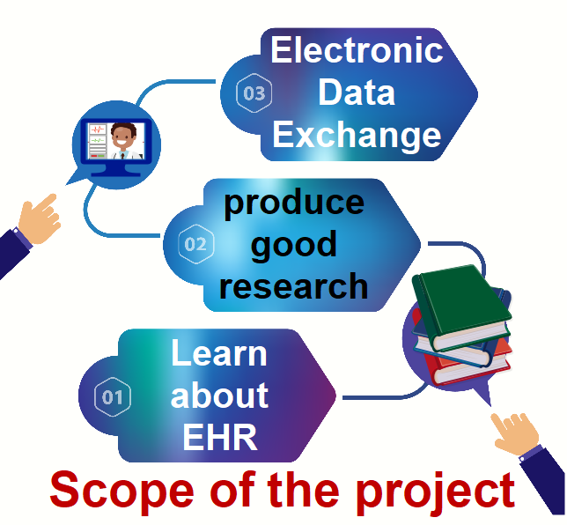

## Technical challenge

# Literature review

Digitalization on health care is one of the demanded developments by patient for maintaining their health by synchronizing with the virtual services. People are lured by the positive aspects of digitalized health services and from one of the real-time surveys (Farber et al. 2015) more than 75% of all patients are choosing to acquire digital health services in the coming days. So, simply digital health care has focus into reducing consumer's health risks and promote well-being of their health. Analyzing that by (Manca 2014), electronic medical records were used by 75% of Canadian physicians which truly depicts the importance of digitalized services. It is just an example of one nation, world widely digital health services are enhancing consumer to get proper health care in an advanced way.

Analyzing the various surveys, it was found that doctors were facing problems in providing face to face care to patients and introducing digitalized health services may intrude their relationship with patients. According to research paper publish in internet, health care digitalization has been difficult to extend furthermore in France due to unavailability of innovation integration. From the study of The Institute of Medicine (IOM) in 1999, medicals errors lead to the death of 98,000 people annually in USA which may have been reduced if digitalized health service was implemented at that time (Carver and Hipskind 2019). While reading journal and papers, it was found that most of the people simply thought about the text messaging systems to its minor. From one of the surveys, it has been found that most of the implementation of digitalized health services have been published from the projects in Norway.

Dr. Robert Hoyt, expert on health informatics explained for practicing electronic health record rather than paper-based health record (Hoyt 2019). Benefits that can be acquired from EHR are explained and recognized EHR as a powerful transformation tool. Limitation of paper-based records, improvement in efficiency and quality health care urged for the implementation of EHR. Data aggregation and integration are the advantages that can be experienced by practicing EHR.

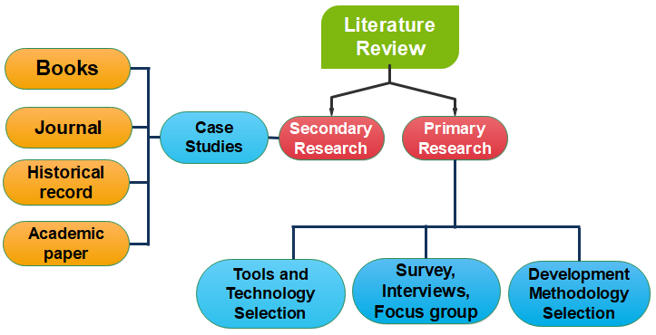A qualitative research was conducted by Ni et al. (2019) for exploring barriers and facilitators of data quality of EHR. 19 health care professionals from 4 tertiary hospitals in Beijing participated in this study and found that the barriers involved for producing quality data were rotations of staff, heavy workload, unstructured data in large amount, data extraction problems and many more. The experienced EHR user suggested that providing staff training in a better way with monetary incentives, improving functionality of software and performing data verification in a regular basis can improve data quality.

## Development Methodology

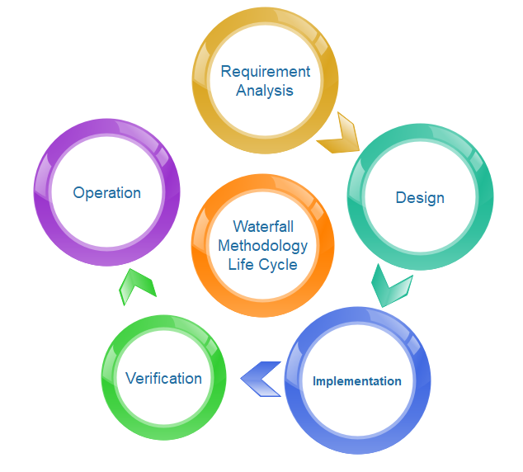Among various methodologies I will be working under waterfall methodologies to build the web application as it is a straight-line approach from start to finish. Waterfall methodology is simply a sequential phrase which fragments a complete project into five phrases and each phrase represent its own importance and are explained below:

Figure 4: Waterfall Development Life Cycle

1. **Requirement analysis:** This is the first phase of waterfall methodology where business analyst gathers and analyze each and every requirement to initiate the project. This is the important phase where proper decision should be made after adequate information.
2. **Design**: This phase can be sub-divided into Logical design and Physical design. Logical design refers to the designation of system's software after collecting enough information from requirement analysis phase. Once the most suitable logical design is completed then it is transformed into a physical design which results into software architecture.
3. **Implementation**: This phase belongs to programmers where software is developed and integrated. After making design as a base, coding of a software is done in this phase.
4. **Verification**: After the implementation phase is rolled out, there is verification phase where software is tested by different ways whether it is ready to be used or not. Defects debugging is done to ensure the smooth operation of software which can match the necessity as requested.
5. **Operation**: This is the final phase of waterfall methodology where software is finally executed. After the execution, the software came into use and as per the recommendation’s and review, maintenance will be done.

## Tools

Following mention picture shows the list of tools that will be used while doing the proposed project.



## Technology

While developing web application, I will be working on client-side and server-side. In below mention pictures, orange color gear refers to client-side technologies where blue color gear refers server-side.



# Client and Audience

Following are the group of targeted people who are engaged directly or indirectly during whole research.

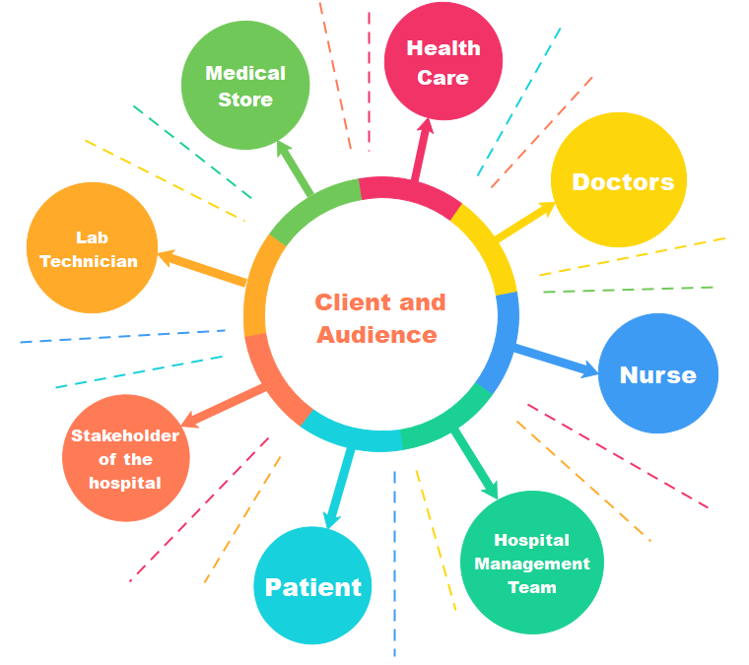

# Motivation

Few months ago, along with my mother when I went to hospital for her regular checkups, she forgot her paper-based report on home. As my home was far from hospital, we couldn’t return back to home to bring those reports as there was 20-minute left for her appointment. Due to that, doctor postponed her appointment to next week. As, she was a heart patient, we were scared about her health. To avoid such problems, my interest emerged on researching in this field. I started to read opinions of researchers active in ResearchGate about the digitalization technique and its consequences along with potential benefit. Many questions have been questioned by the researcher which influence me to read a book Digitalization of healthcare by Karin Garrety, Rob Wilson, Ian P. McLoughlin. There I found many facts about the impact created after adapting the digitalization. So, this topic has been chosen so that I can make a try to solve my own problem and make habit of doing research to learn a new thing.

# Deliverable

## Project plan

Before initializing every project, a project plan must be created in order to drive the project in a control and right path of development. A project plan is key factor to determine the success of project.

## Timing

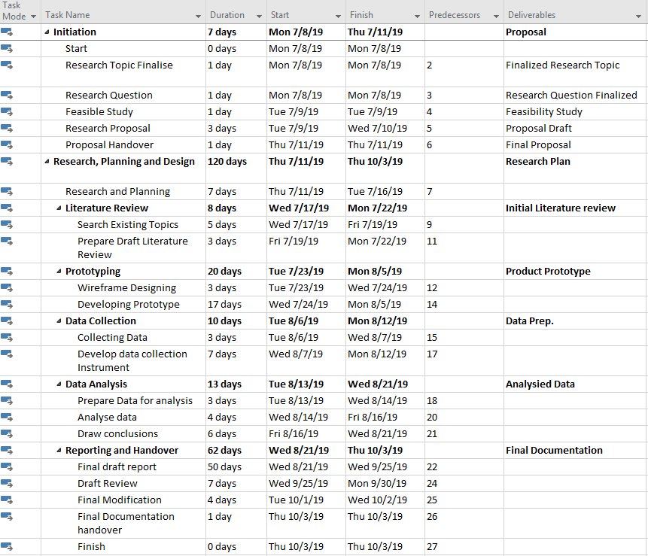

Figure 5: Time Estimation for task

## Gantt Chart

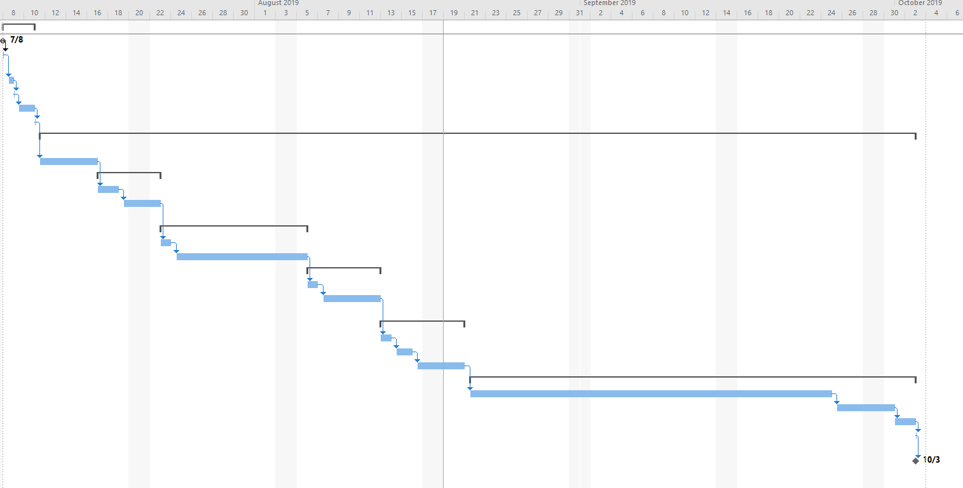

Figure 6: Gantt Chart

## SWOT Analysis

Swot analysis can be referred as checking internal strength and weakness as well as external opportunities and threats that can be possessed for conducting a good research. The SWOT analysis of proposed project is illustrated below:

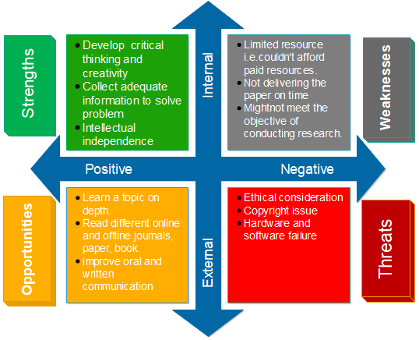

# Bibliography

Duwadi, E. (2016) [online] available from <https://commons.nmu.edu/cgi/viewcontent.cgi?article=1012&context=facwork_bookchapters&fbclid=IwAR1M-NweIsP1gfad6KH7aKkvtz0OGffWz8k3kvbQdwjD3uEzLO65EbHAxq4> [9 June 2019]

*Ehealthnetworknepal / Resources* (2019) available from <https://gitlab.com/ehealthnetworknepal/network> [10 June 2019]

*Electronic Health Records* (2019) available from <https://www.himss.org/electronic-health-records> [11 June 2019]

DT Cultural Heritage. (2019). Types of Digitization | DT Cultural Heritage. [online] Available at: https://dtculturalheritage.com/digitization-program-planning/types-of-digitization/?fbclid=IwAR3dUQR9BB8YJfNVpiPNiPoCMGPgEEi1MJtk1JUXRJE6cG6awO5onrm7xDQ [Accessed 11 June 2019].

Manca, D. (2014) *Do Electronic Medical Records Improve Quality Of Care?: Yes* [online] available from <https://www.ncbi.nlm.nih.gov/pmc/articles/PMC4607324/> [12 June 2019]

Seminarsonly.com. (2019). Digitalization Of Hospital | Computer Science Project Topics. [online] Available at: https://www.seminarsonly.com/Engineering-Projects/Computer/digitalization-of-hospital.php?fbclid=IwAR3_lkyJMGovG-IokOT8NrV2mVUacdU2Basmum4I-H_bBIGIx0fxRTK1qTM [12 June 2019].

Farber, N., Liu, L. and Chen, Y. (2015) *EHR Use And Patient Satisfaction: What We Learned* [online] available from <https://www.mdedge.com/familymedicine/article/103873/practice-management/ehr-use-and-patient-satisfaction-what-we-learned> [15 June2019]

YouTube. (2019). Digital Health and Technology Panel - Stanford Medicine Big Data | Precision Health 2018. [online] Available at: https://www.youtube.com/watch?v=gnN_HYqWWZQ&fbclid=IwAR0WI6EyqHqNtrbYMcNzztaONzNm4HUuenT_wtW4beC6zymFaR-diQj1gv4 [16 June. 2019].

ETHealthworld.com. (2019). The impact of digitization holds strong significance for rural services : Dr. Abhay Chopada - ET HealthWorld. [online] Available at: https://health.economictimes.indiatimes.com/news/industry/the-impact-of-digitization-holds-strong-significance-for-rural-services-dr-abhay-chopada/65329060 [19 June 2019].

Notendur.hi.is. (2019). [online] Available at: https://notendur.hi.is/th/MSritgerdir/How%20to%20Write%20a%20Research%20Proposal.pdf?fbclid=IwAR1ONx3JwprLE_Rvi09uZPo2LdTc4tuzvvMBcpx1xd3PlA6jDY3JpJfMznI [19 June 2019].

Carver, N. and Hipskind, J. (2019) *Medical Error* [online] available from <https://www.ncbi.nlm.nih.gov/books/NBK430763/> [19 June 2019]

NEJM Catalyst. (2019). 7 Challenges and 7 Solutions for Large-Scale EHR Implementation. [online] Available at: https://catalyst.nejm.org/challenges-solutions-ehr-implementation/ [22 June 2019].

Almario, C. (2019). The Effect of Digital Health Technology on Patient Care and Research. [online] PubMed Central (PMC). Available at: https://www.ncbi.nlm.nih.gov/pmc/articles/PMC5572976/ [23 June 2019].

Kuusisto, Markku. (2017). Organizational effects of digitalization: A literature review. International Journal of Organization Theory and Behavior. 20. 341-362. 10.1108/IJOTB-20-03-2017-B003.

*How To Use Bootstrap With HTML* (2019) available from <https://www.bootstrapdash.com/use-bootstrap-with-html/> [23 June 2019]

Shiksha, C. (2017) *What Is AJAX And How It Works* [online] available from <https://www.youtube.com/watch?v=ugiFpA03B6c> [24 June 2019]

Gueutal, H. and Stone, D. (2005) *Brave New World Of EHR: Human Resources Management In The Digital Age (Professional Practice Series)*. Jossey Bass Inc

Lapão, Luis. (2018). Digitalization of Healthcare: Where Is the Evidence of the Impact on Healthcare Workforce' Performance?. Studies in health technology and informatics. 247. 646-650.

Online, F. (2019). Digitization in healthcare: Three ways technology is shaping the future of the sector. [online] The Financial Express. Available at: https://www.financialexpress.com/lifestyle/health/digitization-in-healthcare-three-ways-technology-is-shaping-the-future-of-the-sector/1451441/ [25 June 2019].

McLoughlin, I., Garrety, K., Wilson, R., Yu, P. and Dalley, A. (n.d.). The digitalization of health care.

DT Cultural Heritage. (2019). Types of Digitization | DT Cultural Heritage. [online] Available at: https://dtculturalheritage.com/digitization-program-planning/types-of-digitization/ [25 June 2019].

Côrtes, P. and Côrtes, E. (2019). Hospital information systems: a study of electronic patient records. [online] Scielo.br. Available at: http://www.scielo.br/scielo.php?script=sci_arttext&pid=S1807-17752011000100008 [26 June 2019].

Hoyt, D. (2019) Benefits Of Switching To An Electronic Health Record (EHR) | Practice Fusion [online] available from <https://www.practicefusion.com/health-informatics-practical-guide-page-1/> [28 June 2019]

Ni, K., Chu, H., Zeng, L., Zhao, Y. and Li, N. (2019) Barriers And Facilitators To Data Quality Of Electronic Health Records Used For Clinical Research In China: A Qualitative Study.